Vena Channel Build Summary - December 30, 2025
Created by: Miles Waite
Date: December 30, 2025

Overview
Successfully built and validated two new Vena integration channels, migrating from legacy source (tsv_FULL_GL_PL_old) to new VenaQL source (CL_Full_GL_Source).

Channels Built

Channel 1: 01e.CH_GL_Load_Proj_RPT_FringeAlloc_CL_Miles
Purpose: Load fringe allocation amounts for project GL reporting
Configuration: - Source: CL_Full_GL_Source (VenaQL) - Destination: DM_Project_GL_Load - Data Type: intersections - Aggregation: sum
Results: - Status: COMPLETED - Rows Processed: 168,855 - Values Added: 32,407 - Values Removed: 0 - Execution Time: ~2 minutes
Key Formula: - Fringe_ → Value: =iferror(if(input['Fringe_']=0,ignore,input['Fringe_']*-1),0) - Reverses sign for GL accounting

Channel 2: 01f.CH_GL_Load_Proj_RPT_FringeAlloc_adj_CL_Miles
Purpose: Load fringe adjustment amounts for GL reporting
Configuration: - Source: CL_Full_GL_Source (VenaQL) - Destination: DM_GL_Load - Data Type: intersections - Aggregation: sum
Results: - Status: COMPLETED - Rows Processed: 168,857 - Values Added: 1,558 - Values Changed: 49,886 - Values Removed: 0 - Execution Time: ~2 minutes
Key Formula: - Fringe_ → Value: =iferror(if(input['Fringe_']=0,ignore,input['Fringe_']*1),0) - Keeps original sign for adjustments

Data Validation

Data Validation Checks
- Row Count Validation:
  - Both channels processed ~168,855 rows (consistent with source)
  - Matches expected volume from CL_Full_GL_Source
- Value Range Validation:
  - Fringe adjustment amounts: $32 - $8,755
  - Reasonable distribution of small and large values
  - Mix of positive and negative adjustments (as expected)
- Fringe Rate Validation:
  - Sample calculations from exported data:
    - Base: $1,680 → Fringe: $542.64 (32.3%)
    - Base: $1,640 → Fringe: $529.72 (32.3%)
    - Base: $3,218.75 → Fringe: $1,039.66 (32.3%)
  - Consistent fringe rate of ~32-33%
  - Within expected industry range (25-40%)
  - Note: The 32-33% fringe rate is consistent with typical employer costs
for National Insurance, pension contributions, and other benefits.
- Formula Validation:
  - 01e: Sign reversal working correctly (*-1)
  - 01f: Original sign preserved (*1)
  - Field name precision validated (Fringe_ with underscore)

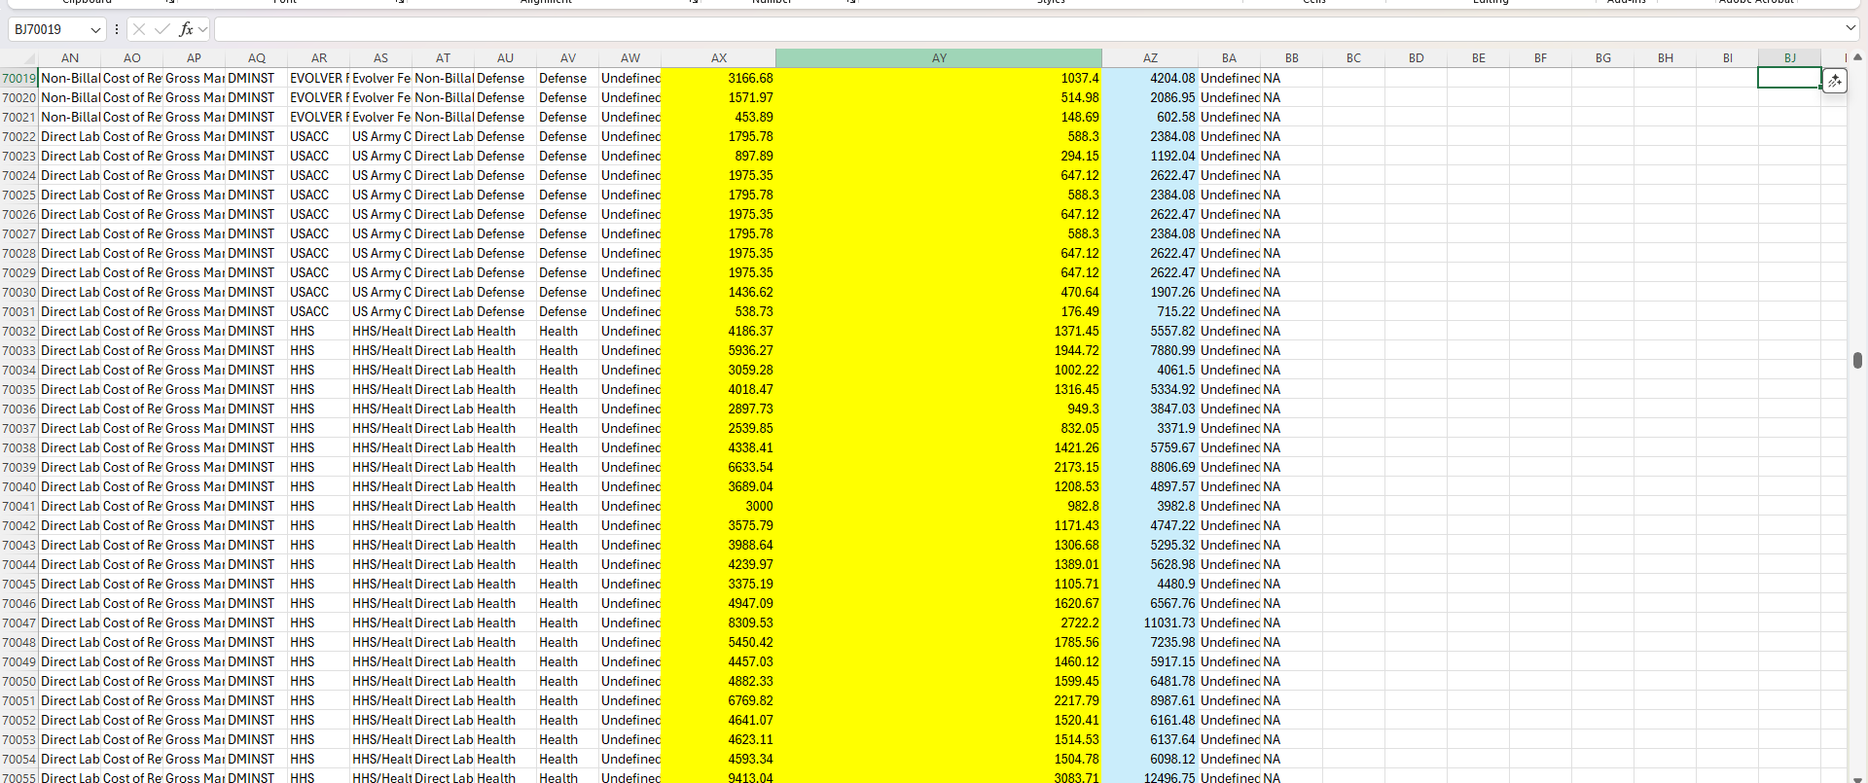

Issues Resolved

Issue 1: Invalid Field Reference
- Error: Formula referenced input['Fringe'] instead of input['Fringe_']
- Resolution: Corrected field name to include underscore
- Lesson: Field names must match exactly

Issue 2: Empty Fixed Mapping - Currency
- Error: Member “” not found in dimension “Currency”
- Resolution: Set Fixed Value to “USD”

Issue 3: Empty Fixed Mapping - Scenario
- Error: Member “” not found in dimension “Scenario”
- Resolution: Set Fixed Value to “Actual”

Issue 4: Empty Fixed Mapping - Measure
- Error: Member “” not found in dimension “Measure”
- Resolution: Set Fixed Value to “Amount”
Key Learning: All Fixed Mappings must have valid dimension member values specified.

Key Mappings Configured

Common Mappings (Both Channels):
- PROJ_RPT_ID → Project Code (with blank filter)
- L1_PROJ_RPT_N through L5_PROJ_RPT_N → L1 through L5
- L1_PROJ_RPT_S → L6
- L2_PROJ_RPT_S → Segment
- L3_PROJ_RPT_S → Employee
- Fiscal_Year → Year
- Period → Period
- Currency → “USD” (Fixed)
- Scenario → “Actual” (Fixed)
- Measure → “Amount” (Fixed)

Differences:
- 01e destination: DM_Project_GL_Load
- 01f destination: DM_GL_Load
- 01e formula: Multiply by -1
- 01f formula: Multiply by 1

Technical Details

Source Configuration
- Source Name: CL_Full_GL_Source
- Source Type: VenaQL query
- Refresh: Performed before channel build to ensure current data

Fixed Mapping Values
- Currency: USD
- Scenario: Actual
- Measure: Amount
Critical Note: Fixed Mapping values must exactly match dimension members in target model. Typos (e.g., “Ampunt” instead of “Amount”) can result in successful execution but data loaded to incorrect/unexpected dimension members.

Production Environment Warning
All work performed directly in LIVE PRODUCTION environment.
No UAT or Integration environment available. All channel builds, testing, and validation performed with live data impacting production reporting.
Precautions taken: - Thorough validation before execution - All formulas tested and verified - Fixed Mapping values confirmed against dimension members - Output data validated post-execution

Documentation Delivered
- Vena_Channel_Build_Guide_Complete.md - Complete step-by-step documentation including:
  - Channel configuration details
  - All field mappings and formulas
  - Troubleshooting log with all errors and resolutions
  - Best practices and lessons learnt
  - Production environment warnings
- Data Export - Excel file with 168,856 rows showing actual loaded data
- This Summary - High-level achievements and validation results

Achievements Summary
2 production channels built from scratch
83,851 total values loaded (32,407 + 1,558 + 49,886)
5 critical errors resolved (field names, fixed mappings)
Data quality validated (fringe rates, ranges, consistency)
Complete documentation created for future reference
Validation checks passed

Next Steps

- Consider scheduling channels for automated execution
- Monitor first few automated runs for consistency
- Add channels to operational runbook

Status: COMPLETE - Both channels production-ready
Validation: PASSED - Data quality confirmed
Documentation: COMPLETE - Full guide available
Approval: Channels renamed by Manager for production use
01e.CH_GL_Load_Proj_RPT_FringeAlloc
01f.CH_GL_Load_Proj_RPT_FringeAlloc_adj
Status: approved

